Impressions of CSY 32

When I received the invite for Palle Srujana CSY 32, went through the route on google maps and noted the remote tribal villages to be visited, I immediately made up my mind that I should participate and not miss this opportunity. This was my 3rd CSY the first one to Achampet, Mehboob Nagar, second one to Banswara, Nizamabad. It was also close to my work place Guntur just a four hour journey which was convenient.

I was really happy to see the beautiful nature awash with overnight rains and continuing light drizzle after an hour ride from Khammam to Yellendu, the starting point of a 3 day journey to look for, share the innovations and felicitate the grass root innovators.

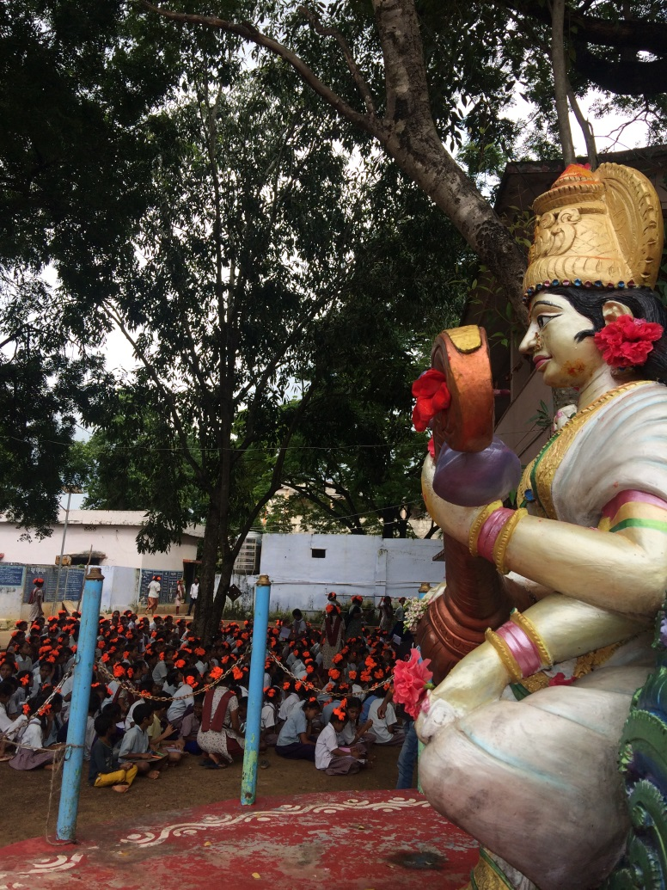
The journey was through the beautiful route of hills and valleys, resplendent nature, full of greenery with forests and crops. The yatris were a bunch of like minded youth and a few seniors. The purpose and spirit of journey was continuously kept high by Brigadier Ganesham garu sharing the stories / innovations and provoking the thoughts on various topics like rural and urban development, identification and promotion of innovations, ethics of Palle Srujana etc. Not a single moment of drudgery felt inspite of long walk in hot/ humid sun and a couple of times the heavy showers brought the relief and happiness. It has been years that I got soaked in rain and nature this unique way. A connect to the Mother Nature has been reestablished making the body and mind forget the fatigue and stress and invigorating the new energies of happiness and creativity.

The motley group of youth, their inquisitiveness to ask questions and understand / learn the rural realities was very heartening.

Thanks to Brigadier Ganesham and the Team at Palle Srujana for these wonderful experiences and great service they are doing to grassroots innovators. Very inspiring work indeed.

Thanks & Best Regards,

Nirmal Reddy

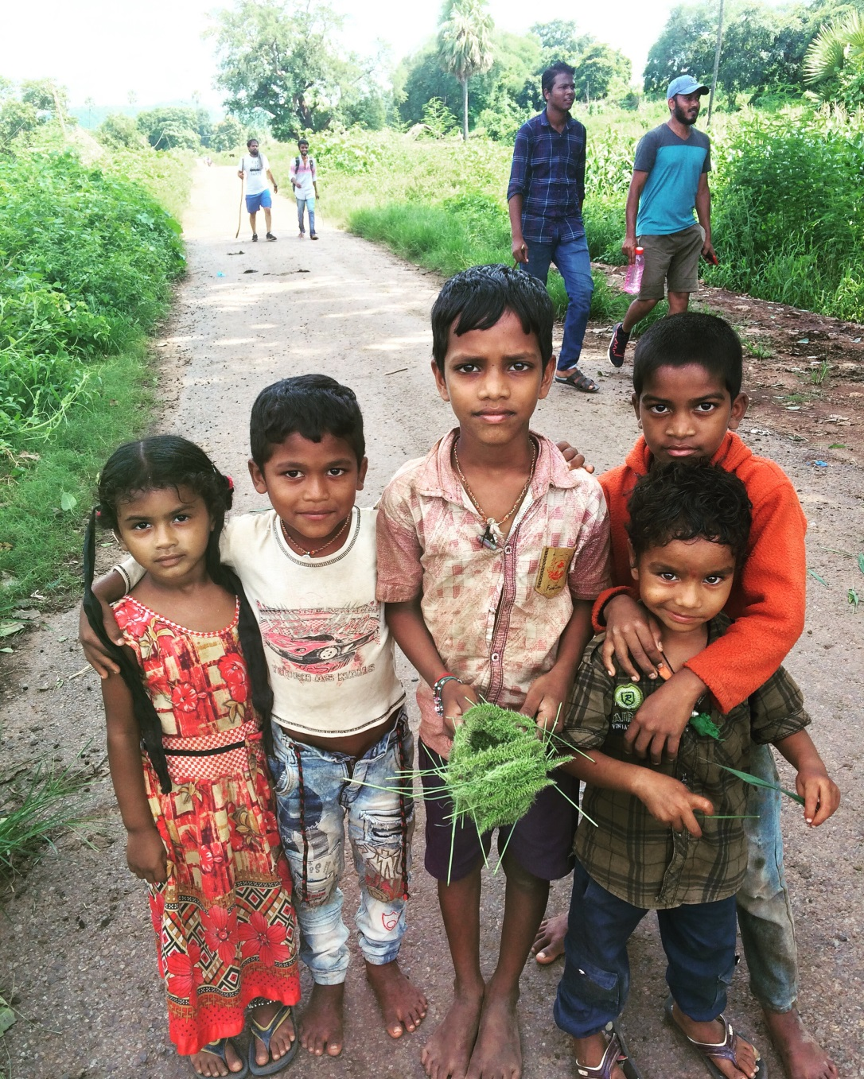
Would like to say a few words on the pic of 5 small kids. This was in the last village we assembled.

These kids were playing and I noticed a boy making some thing with soft grass. When I asked him what he is making, he replied “Iam Making a Nest for Birds to lay eggs “ .
How beautiful and what love these kids have for nature.

The boy is in the centre holding the green grass nest.

